Submission by:

Tikhon Riazantsev

Agastya Heryudhanto

Exercise sheet 7

TASK 1: POLYNOMIAL KERNELS

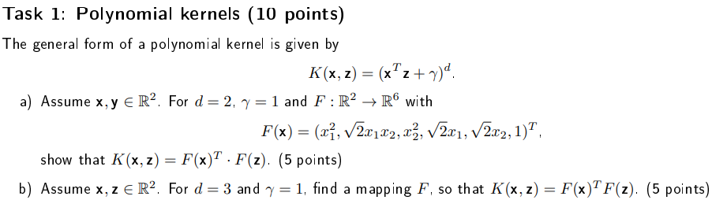

Solution:

1. Let us first find the result of the kernel function:

$$K\left(x,z\right)={\left({\left(\begin{matrix}x_{1} \\ x_{2}\end{matrix}\right)}^{T}\left(\begin{matrix}z_{1} \\ z_{2}\end{matrix}\right)+1\right)}^{2}={\left(x_{1}z_{1}+x_{2}z_{2}+1\right)}^{2}==x_{1}^{2}z_{1}^{2}+x_{1}x_{2}z_{1}z_{2}+x_{1}z_{1}+x_{1}x_{2}z_{1}z_{2}+x_{2}^{2}z_{2}^{2}+x_{2}z_{2}+x_{1}z_{1}+x_{2}z_{2}+1==x_{1}^{2}z_{1}^{2}+x_{2}^{2}z_{2}^{2}+2x_{1}x_{2}z_{1}z_{2}+2x_{1}z_{1}+2x_{2}z_{2}+1$$

Now we can find the dot product of $F\left(x\right)∙F\left(z\right)$ and compare the results:

$$F\left(x\right)∙F\left(z\right)={\left(x_{1}^{2},\sqrt{2}x_{1}x_{2},x_{2}^{2},\sqrt{2}x_{1},\sqrt{2}x_{2},1\right)}^{T}\left(z_{1}^{2},\sqrt{2}z_{1}z_{2},z_{2}^{2},\sqrt{2}z_{1},\sqrt{2}z_{2},1\right)==x_{1}^{2}z_{1}^{2}+2x_{1}x_{2}z_{1}z_{2}+x_{2}^{2}z_{2}^{2}+2x_{1}z_{1}+2x_{2}z_{2}+1==x_{1}^{2}z_{1}^{2}+x_{2}^{2}z_{2}^{2}+2x_{1}x_{2}z_{1}z_{2}+2x_{1}z_{1}+2x_{2}z_{2}+1=K(x,z)$$

1. Let us first find the result of the second kernel function:

$$K\left(x,z\right)={\left({\left(\begin{matrix}x_{1} \\ x_{2}\end{matrix}\right)}^{T}\left(\begin{matrix}z_{1} \\ z_{2}\end{matrix}\right)+1\right)}^{3}={\left(x_{1}z_{1}+x_{2}z_{2}+1\right)}^{3}=$$

$$=\left(x_{1}z_{1}+x_{2}z_{2}+1\right)\left(x_{1}^{2}z_{1}^{2}+x_{2}^{2}z_{2}^{2}+2x_{1}x_{2}z_{1}z_{2}+2x_{1}z_{1}+2x_{2}z_{2}+1\right)=$$

$$=x_{1}^{3}z_{1}^{3}+x_{1}x_{2}^{2}z_{1}z_{2}^{2}+2x_{1}^{2}x_{2}z_{1}^{2}z_{2}+2x_{1}^{2}z_{1}^{2}+2x_{1}x_{2}z_{1}z_{2}+x_{1}z_{1}+$$

$$+x_{2}^{3}z_{2}^{3}+x_{1}^{2}x_{2}z_{1}^{2}z_{2}+2x_{1}x_{2}^{2}z_{1}z_{2}^{2}+2x_{2}^{2}z_{2}^{2}+2x_{1}x_{2}z_{1}z_{2}+x_{2}z_{2}+$$

$$+x_{1}^{2}z_{1}^{2}+x_{2}^{2}z_{2}^{2}+2x_{1}x_{2}z_{1}z_{2}+2x_{1}z_{1}+2x_{2}z_{2}+1=$$

$$=x_{1}^{3}z_{1}^{3}+x_{2}^{3}z_{2}^{3}+3x_{1}^{2}z_{1}^{2}+3x_{2}^{2}z_{2}^{2}+3x_{1}^{2}x_{2}z_{1}^{2}z_{2}+3x_{1}x_{2}^{2}z_{1}z_{2}^{2}+6x_{1}x_{2}z_{1}z_{2}+3x_{1}z_{1}+3x_{2}z_{2}+1$$

Assume the following mapping function F and check to see if it fits the criteria:

$$F\left(x\right)=\left(x_{1}^{3}, x_{2}^{3}, \sqrt{3}x_{1}^{2}, \sqrt{3}x_{2}^{2}, \sqrt{3}x_{1}^{2}x_{2},\sqrt{3}x_{1}x_{2}^{2},\sqrt{6}x_{1}x_{2},\sqrt{3}x_{1},\sqrt{3}x_{2},1\right)$$

$$F\left(x\right)∙F\left(z\right)=\left(x_{1}^{3}, x_{2}^{3}, \sqrt{3}x_{1}^{2}, \sqrt{3}x_{2}^{2}, \sqrt{3}x_{1}^{2}x_{2},\sqrt{3}x_{1}x_{2}^{2},\sqrt{6}x_{1}x_{2},\sqrt{3}x_{1},\sqrt{3}x_{2},1\right)∙$$

$$∙\left(z_{1}^{3}, z_{2}^{3}, \sqrt{3}z_{1}^{2}, \sqrt{3}z_{2}^{2}, \sqrt{3}z_{1}^{2}z_{2},\sqrt{3}z_{1}z_{2}^{2},\sqrt{6}z_{1}z_{2},\sqrt{3}z_{1},\sqrt{3}z_{2},1\right)=$$

$$=x_{1}^{3}z_{1}^{3}+x_{2}^{3}z_{2}^{3}+3x_{1}^{2}z_{1}^{2}+3x_{2}^{2}z_{2}^{2}+3x_{1}^{2}x_{2}z_{1}^{2}z_{2}+3x_{1}x_{2}^{2}z_{1}z_{2}^{2}+6x_{1}x_{2}z_{1}z_{2}+3x_{1}z_{1}+3x_{2}z_{2}+1=$$

$$=K(x,z)$$

Which means the mapping function is correct.